A basic guide to health care for children with Down’s syndrome
by Gail Hogan (Secretary of SDSSG)
The life expectancy today of someone with Down’s syndrome is 60 years of age, compared to 23 years of age in 1983 and sadly just 10 years of age in 1910. This shows the huge advances in medical knowledge into the health matters and social care needs that are associated with Down’s syndrome. There are a number of health conditions associated with this syndrome, some may be present from birth whilst others appear later on or come and go with time. Research suggests many people with Down’s syndrome have a higher tolerance of pain, add this to communication difficulties and the result can quite easily be unidentified health issues.
The health chart produced by the DSA is great at detailing the main areas to be checked and when. But, like anything, they can’t put everything you need to know down as the list has to end somewhere.
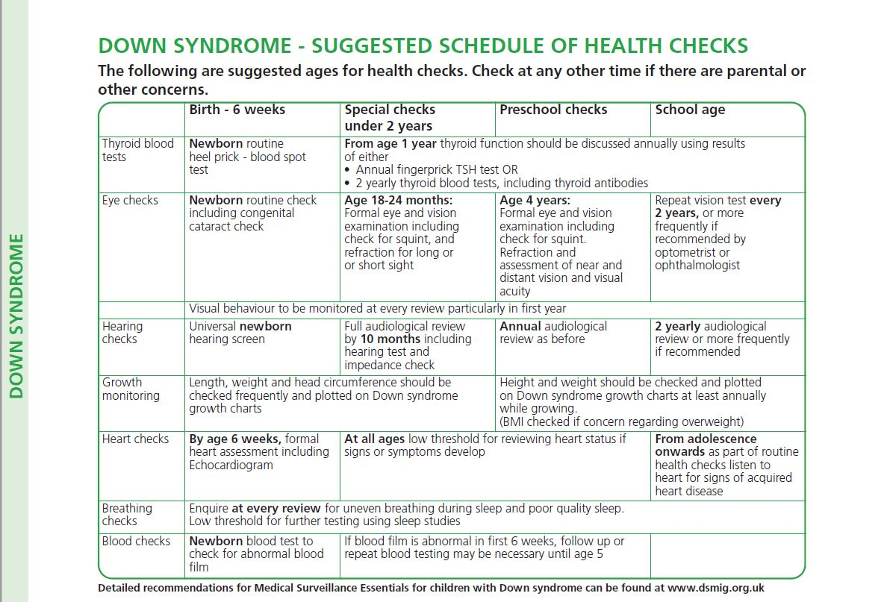

https://www.downs-syndrome.org.uk/for-families-and-carers/health-and-well-being/personal-child-health-record-insert-for-babies-and-children/

Here are some of those that haven’t made it on the list:
So what about our children’s podiatry needs – feet and lower limbs?
Many children with Down’s syndrome have problems with the way that they walk and their feet, generally linked to hyper-flexibility. Orthopaedic problems are associated with low muscle tone and loose ligaments. Common foot and lower limb problems associated with Down’s syndrome include:
- Flat feet
- Tip toe walking
- Tripping
- Smaller legs, feet and toes
- Limited ankle movement
These lower limb problems can produce a number of painful symptoms which should be treated by a podiatrist. So the question to ask yourself and your child:
Are you concerned about the way they walk?
Is your child experiencing any pain or problems with the lower limb or foot?
If you are concerned or unsure make a request for an assessment, early help is best.

What about sleep apnoea?
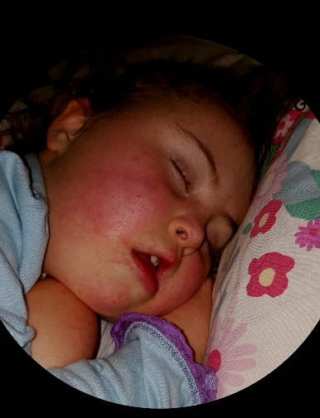
You may be asked frequently if your snores, if you answer no, the Dr may well say “ok” and follow through to the next question. Sleep apnoea is more common in those with Down’s syndrome due to various physical characteristics associated with the condition including floppy muscles in the throat, enlarged tonsils and adenoids and a smaller upper airway. It is suggested 50 – 80% of children with Down’s syndrome have some degree of sleep apnoea.
Night time features of sleep apnoea include combinations of loud snoring or coughing or choking noises, restless sleep, sleeping with the head tipped back (to try to open up the airway), other unusual sleeping positions, repeatedly interrupted breathing, excessive sweating and possibly bedwetting.
It is strongly recommended children with Down’s syndrome have a sleep study before age 2. This usually involves an oxygen probe being attached to their toe/ foot for the night which can then monitor what’s happening when they are sleeping. Most sleep study’s take place at home. The device records the information which is then looked at by a specialist.
We all know the feeling and impact of lack of sleep, if your child has sleep apnoea then this is likely to impact on their mood and behaviour, concentration and energy levels. A simple test can help eliminate or identify problems.

Incontinence
Children with Down’s syndrome are likely to take longer than other children with toilet training. So what happens when they become too big for the supermarket stocked nappies? For children aged 4+, the incontinence service, currently based in Telford, will conduct an assessment. If it is agreed your child requires incontinence pads (oversized nappies) a prescription will be raised for 4 (yes FOUR) per day. These will be delivered to your home in bulk quantities.
Current contact details for the Continence Advisory Team are 01952 580328.

Dental
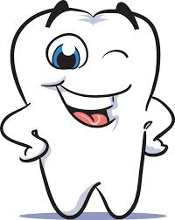
Children and adults with Down’s syndrome are prone to experience more dental problems than the rest of the population. This is due to having a smaller mouth cavity, dry mouth (with more viscous saliva), delayed tooth eruption and missing permanent teeth. Developing and maintaining the habit of effective teeth brushing is important to ensure that dental problems are minimised. Dental checkups for children should take place 6 monthly, there is no reason why your family dentist can not offer this to your child. However, if necessary there are dentists who have experience in looking after people with a learning disability.
http://www.shropscommunityhealth.nhs.uk/routine-dental-treatment

**Regular checkups are important to prevent serious health problems because of the heart conditions commonly associated with Down’s syndrome.**

Digestive system
From constipation to many loose bowel movements a day, the range of problems can vary. These difficulties can be linked to eating problems, mouth ulcers and hyperthyroidism. Coeliac disease (an allergy to gluten) and lactose intolerance (the sugar found in cow’s milk) can also be quite common in those with Down’s syndrome.
If in doubt, check it out.

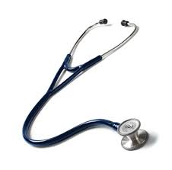
Respiratory System
The winter bugs can really impact children with Down’s syndrome. Chest infections and breathing problems are common due to the structure and function of the airways. You may want to speak with your child’s GP or community paediatrician about a winter course of low dose antibiotics to offer a boost to your child.
**Chest infections still remain a major cause of death in adults with Down’s syndrome (2014).**

Hearing and related issues
Hearing and ear related issues are often life-long issues for people with Down’s syndrome; this is related to the structure of the ear. Problems may be difficult to detect and regular screening is therefore important. The earlier the identification of the problem the better the outlook after treatment.
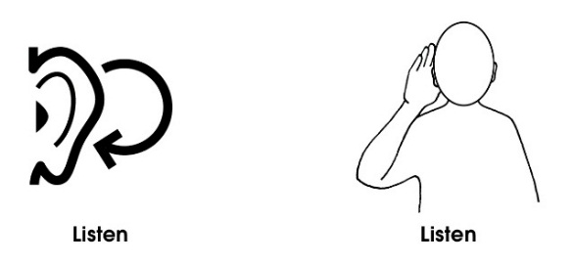
Glue ear is a build-up of wax in the ear canal; this can cause mild to moderate hearing loss. Glue ear can come and go, therefore hearing loss can also come and go. This can lead to parents or teachers describing a child as having ‘selective hearing’.
If the person with Down’s syndrome, you as the parent or any staff are concerned about a hearing problem then a doctor’s opinion should always be sought.

Vision and related issues
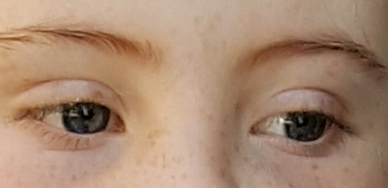
A significant number of children with Down’s syndrome are reported to have problems with their vision: short- sightedness, long-sightedness, astigmatism and other visual impairments are common.
Everyone with Down’s syndrome will have poor visual acuity. This means they will see the world differently, with less fine details, even when wearing glasses; compare reading something written in faint pencil to a black pen. There is information from the DSA around ‘Think BIG, think BOLD’, this gives practical examples of ways to support.
The Sensory Inclusion Service (SIS) supports children and young people with hearing and/or visual difficulties and their families.
http://www.telfordsend.org.uk/localofferservices/info/1/home/18/sensory_inclusion_service
Undiagnosed health problems may add significantly to the level of delay already experienced and also may be misconstrued as part of the child’s condition or them just being “difficult”.
If in doubt, check it out.

